Common Applications

Bogdan Tatu – Gr. 3.1

* Using UDP port 67

1. 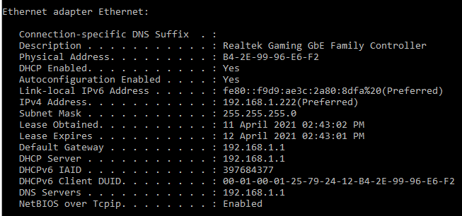Ipconfig /all

We need ipconfig /all to get all the information that changes between initial conditions and the renewal process.

IP: 192.168.1.222

MAC: B4:2E:99:96:E6:F2

1. 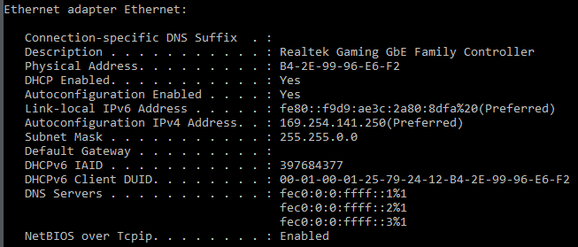Ipconfig /release
2. Modifications:

No more normal IPv4 Address, only an Autoconfiguration IPv4 Address.

Lease is non-existent for the time being.

There’s no Default Gateway and DHCP Server.

MAC Address the same as before.

1. 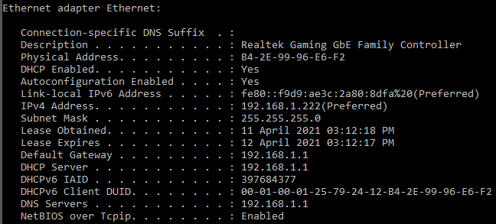Ipconfig /renew
2. Modifications:

Got the same IPv4 address as before.

Acquired a new lease at the time of renewal.

MAC address the same throughout the process, since it’s a physical address.

1. 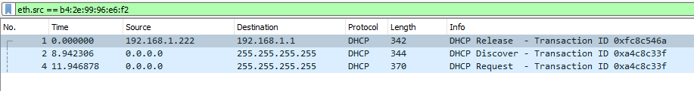Trace file messages: eth.src == B4:2E:99:96:E6:F2 ( My MAC Address )
2. Time to get IP address: Discover Time – ACK Time

Discover Time: 98.125535s

ACK Time: 101.187463s

Time: 3.061928s

1. Longest Loading Time Element: Ads…

23. googleads.g.doubleclick.net – ads ( time: 643ms )

1. DNS Identification Time:

114ms

